1. **Product Selection Hyperlink.**

A new feature called "Hyperlink option" has been introduced to the product management screen. This feature enables you to add a URL that will be displayed in the application's product selection screen.

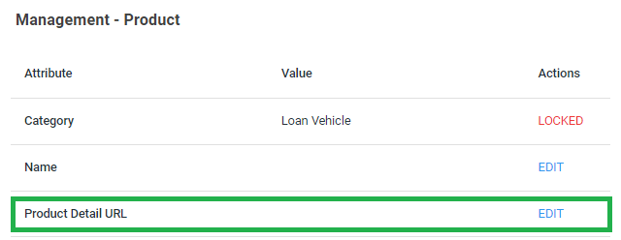

An additional hyperlink has been incorporated beneath the "View" button, allowing users to access a webpage where they can view detailed information about the product.

The hyper link will display when multiple products are displayed.

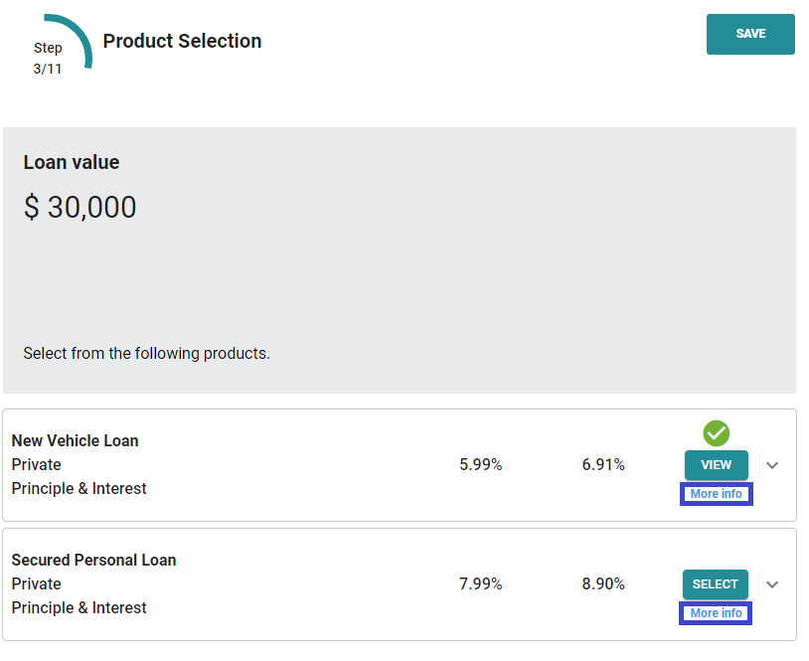

1. **Product Selection via Merchant Portal**

Now, users have the capability to select all products listed under a specific product category in the application's "Product" tab.

This feature proves beneficial in cases where customers or merchants find another product more suitable for their needs compared to the one, they initially applied for. With this functionality, they can easily switch to the preferred product.

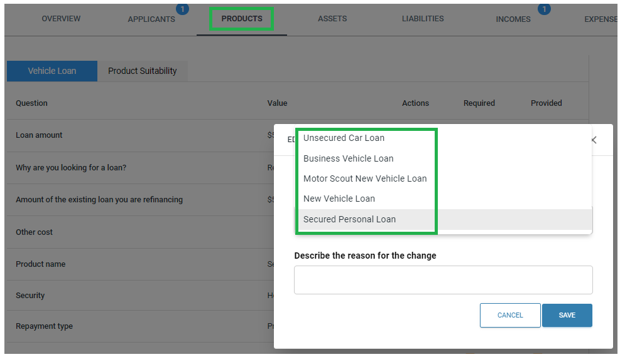

1. **Loan Vehicle Categorisation: Age-based Identifier for New/Used/Unsecured Vehicles**

The Loan Vehicle category now offers merchants the option to enter an identifier that specifies whether the vehicle is new, used, or unsecured.

To achieve this, we have introduced a new feature in the product management screen. Within this feature, merchants can input the minimum and maximum age range of the vehicle.

Nimo will then compare these details with the vehicle's manufacture/build date inputted in the application form and appropriately display the associated product in the product selection screen.

This enhancement allows for better categorisation and selection of loan products based on the vehicle's age, making it easier for merchants to offer suitable loan options to their customers.

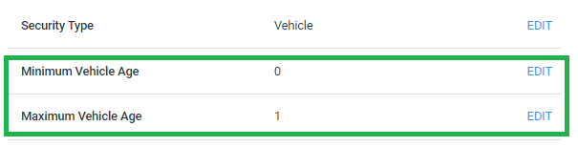

1. **Conditional Approvals**

**Setup**

1. Send your conditional approval letter template to NIMO for parameter updates.
2. NIMO will then provide you with a template for future reference and upload it to their system.

Enable Conditional Approvals:

1. Go to the management layer.
2. Navigate to the "Product" tab and select the desired product.
3. Activate “conditional approval” by selecting “YES”.
4. Upload the Conditional Approval Letter Template

To ensure that customers receive email or SMS notifications when their loan has been conditionally approved, please navigate to the Company Settings layer, select the "Communication tab," then click on "Application Conditionally Approved Notification." Fill out the required details and customise the content accordingly.

**Merchant Portal**

By clicking the "Conditional Approve" button, you will be redirected to the conditional tab. From there, you can choose conditions to add from the dropdown menu or manually enter your own condition. There will be three category options available for you to choose from.

You will have 3 options as a category.

1. Upload: This option allows customers to view the condition within their customer portal and upload the required documents.
2. Staff: Customers will not see this condition, and it is the responsibility of the staff member to upload the necessary documents.
3. Info: Customers can view these conditions as informational, providing them with additional information.

After adding the conditions, please click the "Save" button located at the bottom of the screen. This action will redirect you to the application layer and the conditional tab, where you can view the added conditions and download the conditional approval letter.

To enable customers to upload their documents, navigate to the assessment layer, then, click on the "Notify Customer" button.

1. **Product Tab Change Log.**

A change log has been implemented on the right-hand side, similar to the change log on the applicant tab. This change log will keep a record of any modifications or updates made to the product tab, allowing users to track and review the changes over time.

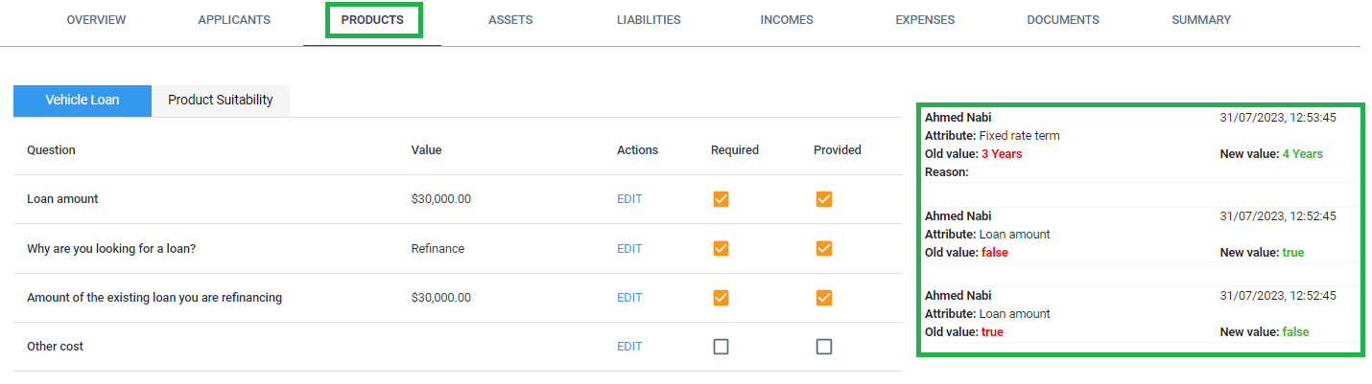

1. **Income Employment- customer name display**

The applicant's name will now be displayed alongside their income.

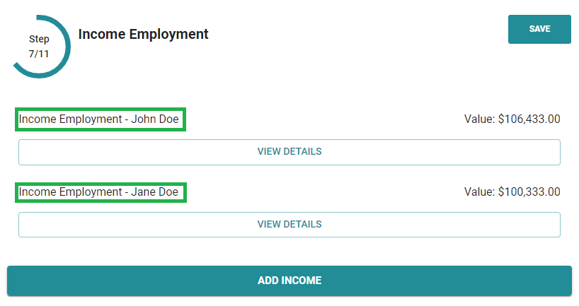

1. **Income Delete Option Introduced to Merchant Portal's Application Layer**

The merchant portal now allows users to delete an income entry. Any deletions made at the application layer will be reflected in the assessment layer.

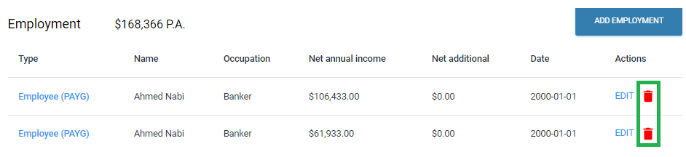

1. **Stop & Cancel Direct Debit / On Off Repayments**

A new report has been introduced, providing a view of all pending and upcoming direct debits.

With this report, merchants now have the capability to stop upcoming recurring direct debits or cancel one-off repayments. However, it is essential to note that the option to stop or cancel repayments is only available before the payment advances to the pending stage, where the direct debit is already in the processing phase.

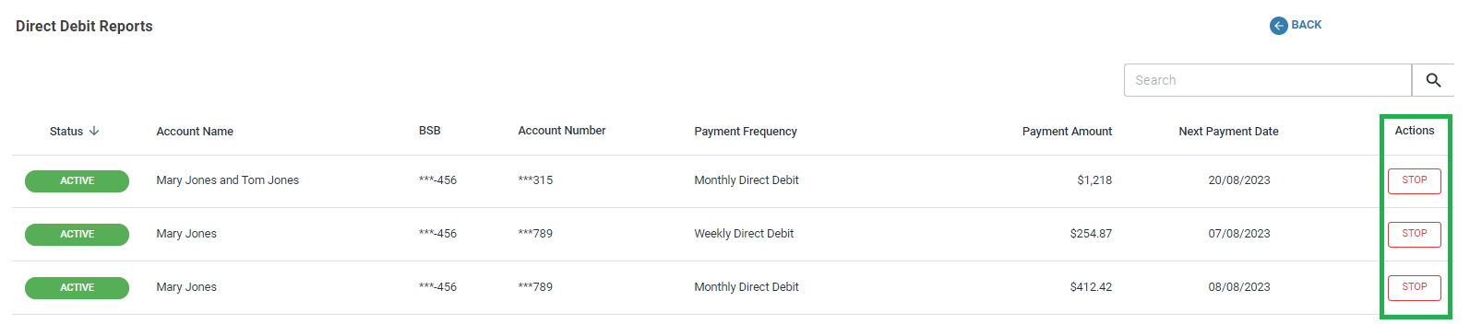

1. **Delinquency Report (enable/disable per customer)**

A new status option has been implemented within the report, enabling the display of all active delinquencies per customer. Moreover, merchants now have the ability to individually disable delinquency for specific customers, offering greater flexibility compared to the previous global setting where delinquency applied universally to all customers. This enhancement allows for more tailored and precise control over delinquency management.

*\*Note this feature will move to the new future “Credit Management” menu in the upcoming sprint*

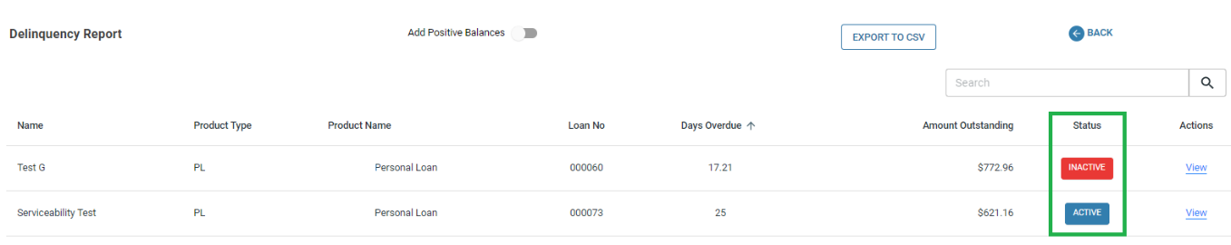

1. **Occupation Codes - ANZSCO**

Merchants now possess the capability to customise the number of digits for Occupation Codes in the Company Settings layer under Occupation Codes - ANZSCO, allowing them to tailor the system to their unique requirements. The Occupation Codes themselves can range from 1 to 6 digits.

This functionality is made available through the form builder, granting both customers and merchants the freedom to select industry-specific Occupation Codes either through the customer application form or the merchant portal.

The Occupation Codes have been sourced from the official website of the Australian Bureau of Statistics at [ABS.GOV.AU](https://www.abs.gov.au/statistics/classifications/anzsco-australian-and-new-zealand-standard-classification-occupations/latest-release)

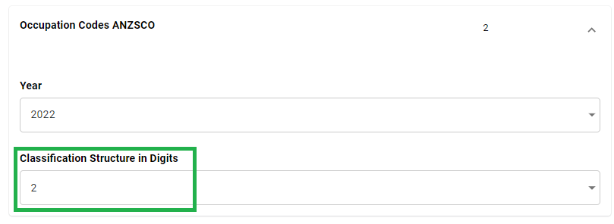

1. **Loan repayments include Monthly/Annual fees in calculation displays.**

Merchants can now include or omit fees on the "product selection" page for loan repayments. To activate this functionality, navigate to the company settings and access the general setting tab. Within the tab, expand the "Loan Repayment Calculation" section and toggle the option to either "YES" or "NO" for enabling or disabling the feature.

For fee information, refer to the pricing table located within the Management layer. Select the desired product, and within the "Interest Rate & Fee" field, click on "view." You'll find the annual fee column, which can be utilised for setting up monthly fees as well. If you opt for monthly fees, you can enter the total amount in this field, and the system will automatically calculate the corresponding charges based on the customer's chosen product and loan frequency.

1. **Split Applicant ID – separate customer portal inc. MFA**

Each customer on the application will receive their personalised customer portal link, which will be secured with Multi-Factor Authentication (MFA).

1. **External Penetration Testing continued**